NDIP11 Abstract Submission: HOW TO

Dear Collegues

The Conference Abstract Submission is managed via the CDS Indico.
In order to submit you abstract you have to:

- READ THIS NOTICE UP TO THE END (point 5)

- Reach the NDIP11 Indico page
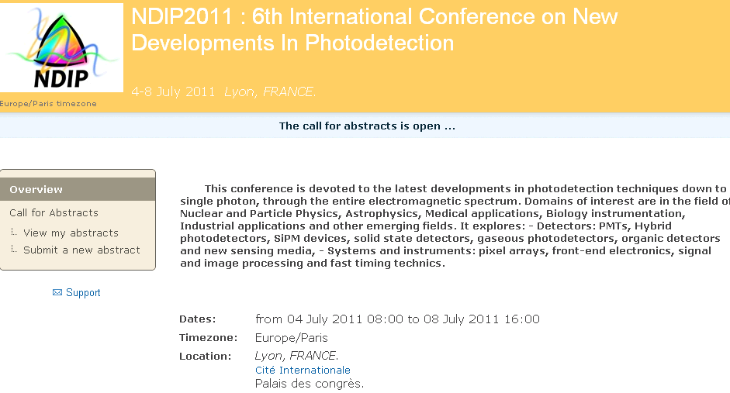

- Click “the Submit a new abstract” in the overview panel (upper-left)
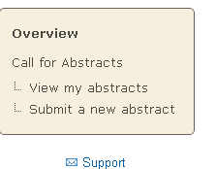
- Log in Indico:

You need to create a new account if not yet done
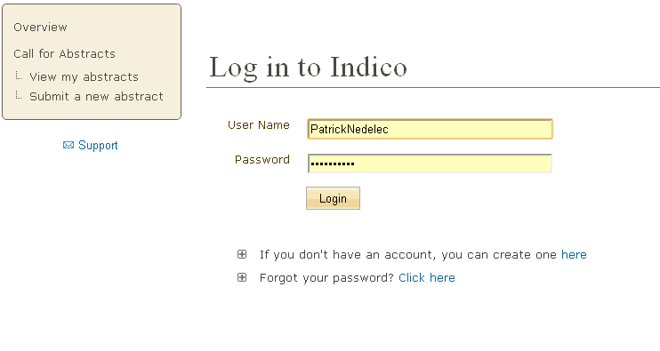

- Fill the Form:
Title, Abstract, Primary Authors, Co-authors, Track classification and Comment.
All those fields are Text type (ASCII) format. Just enter them in the appropriate boxes.

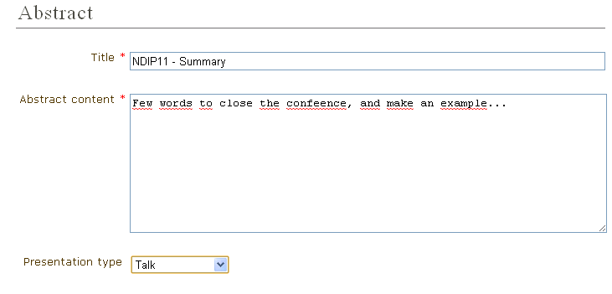

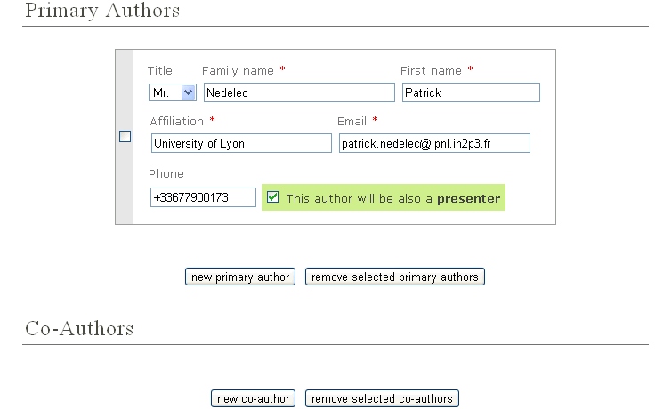

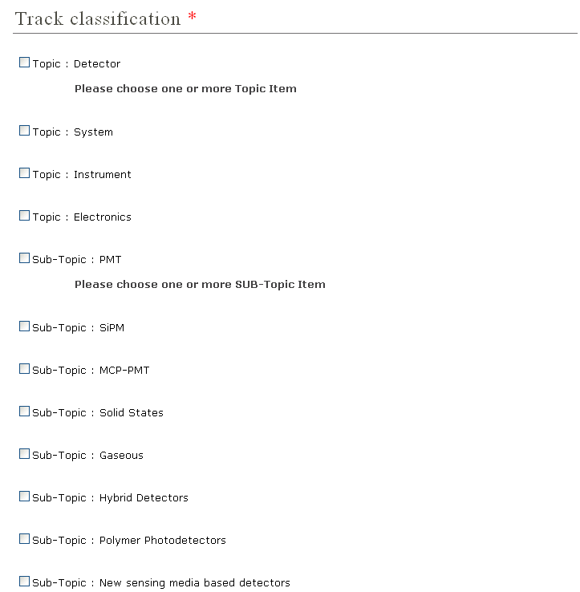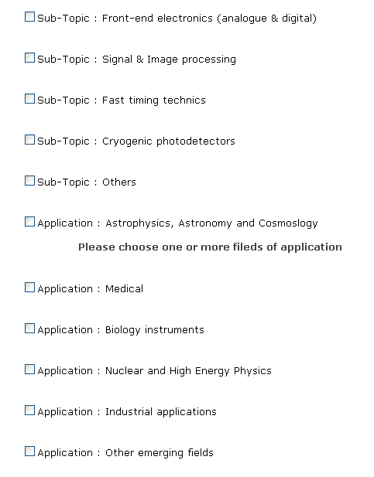

--- EXTRA NEEDS – MANDATORY ---

- Short Notice

We need you to send to us a short notice (abstract summary) to help for the abstract selection by the referees.

It should be 1-2 pages long, in pdf format.

Send it to: ndip-abstracts@in2p3.fr

That’s all !!!

Thank’s reading the notice up to the end.

See you soon at NDIP11

